We’re providing Office to students and staff free of charge. With Office 365, you will now have access to the latest version of Word, for writing; Excel, for spreadsheets; PowerPoint, for presentations; OneNote, for organization and note taking; and much more.
- You must use your school email address
- Install on up to 5 of your personal devices compatible PCs and Macs, plus 5 tablets (including iPad!)
- Gain valuable skills on the world’s most popular productivity software
- Office subscription lasts for as long as you are enrolled in Dillon School District Four

For PC and Mac:
- Visit Office.com/GetOffice365
- Click through to sign in with school-provided credentials

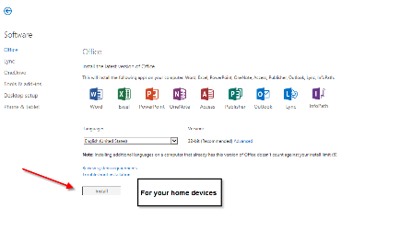
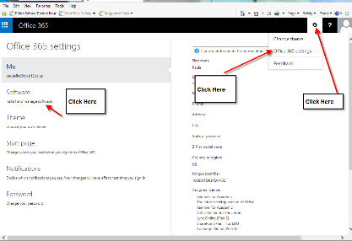

For iOS and Android:
- Download from your app store
iPad: Word, Excel, PowerPoint
iPhone
Android
- Sign in with your school credentials for full editing capability

